Title should not Exceed 100 Total Characters (Palatino Linotype, 18, Bold)
Author Name¹*, Author Name² and Author Name³ (Palatino Linotype, 10, Bold)
- Job title, Department/Division/Institute, Organization, Country, Telephone, Email (Palatino Linotype, 10, Italic)
- Job title, Department/Division/Institute, Organization, Country, Telephone, Email
- Job title, Department/Division/Institute, Organization, Country, Telephone, Email

ABSTRACT (Palatino Linotype, 11, Bold, capital letterS)
Introduction: The abstract should be written in American English, with an appropriate language for an international technical publication, and not exceed 600 total words. The abstract must include an Introduction, Methodology, Results and Conclusions (Abstracts should not contain references, bibliography or bullets). Acronyms or nomenclature used in the text must be explained. Tables, graphics and images are accepted (2 or 3 graphic pieces are the maximum allowed).
The introduction is the concise presentation on the content of the investigation, which provides vital information about its purpose and importance. It must contain brief background about the topic, highlight its relevance, motivation, to present the what, why and how on the subject, the objectives and present guidance about the organization of the text. Text text text text text text text text text text text text text text text text text text text text text text text text text text text text text text text text text text text text text text text text text text text text text text text text text text text text text text text text text text (Palatino Linotype, 10, Normal)

Methodology: Text text text text text text text text text text text text text text text text text text text text text text text text text text text text text text text text text text text text text text text text text text text text text text text text text text text text text text text text text text text text text text text text text text text text text text text text text text text text text text text text text text text text text text text text text text text text text text ext text text text. (Palatino Linotype, 10, Normal)
Table 1 Table header (Palatino Linotype, 10, Left aligned)
Text | Text text text
Text | number, text
Text | number, text

Text text text text text text text text text text text text text text text text text text text text text text text text text text text text text text text text text text text text text text text text text text text text text text text text text text text text text text text text text text text text text text text text text text text text text text text text text text text text text. (Palatino Linotype, 10, Normal)

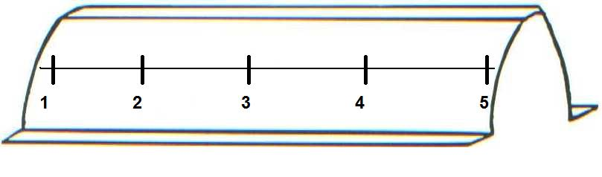
Figure 1 Figure footer (Palatino Linotype, 9, Centered)
Results and Conclusions: Text text text text text text text text text text text text text text text text text text text text text text text text text text text text text text text text text text text text text text text text text text text text text text text text text text text text text text text text text text text text text text text text text text text text text text text text text text text text text text text text text text text text text text text text text text text text text text text text text text text text text text text text text text text text text text text text text text text text text text text text text text text text text text text text text text text text text text text text text text text text text text text text text text text text text text text text text text text text text text text text text. (Palatino Linotype, 10, Normal)

*Corresponding author: Department/Division/Institute, Organization, Position, Complete Postal Address of Company. Phone: +XX XX XXXXXXXX. Email: abcd@abcd.com

